**DAILY ONLINE ACTIVITIES SUMMARY**

|  |  |  |  |  |  |  |  |  |
| --- | --- | --- | --- | --- | --- | --- | --- | --- |
| **Date:** | **17-7-2020** | | | | | **Name:** | **Prajna** | |
| **Sem & Sec** | **8th sem ‘B’** | | | | | **USN:** | **4AL16CS067** | |
| **Online Test Summary** | | | | | | | | |
| **Subject** | | **-** | | | | | | |
| **Max. Marks** | | **-** | | **Score** | | | **-** | |
| **Certification Course Summary** | | | | | | | | |
| **Course** | **Introduction to CSS** | | | | | | | |
| **Certificate Provider** | | | **Great learning** | | **Duration** | | | **5hrs** |
| **Coding Challenges** | | | | | | | | |
| **Problem Statement:**1**.** Write a c program to find two repeating numbers in array. | | | | | | | | |
| **Status: Completed** | | | | | | | | |
| **Uploaded the report in GitHub**  **GitHub link:** | | | | | **Yes**  **https://github.com/alvas-education-foundation/prajna_k** | | | |
| **If yes Repository name** | | | | | **prajna_k** | | | |
| **Uploaded the report in slack** | | | | | **yes** | | | |

Online Test Details: (Attach the snapshot and briefly write the report for the same)

Certification Course Details: (Attach the snapshot and briefly write the report for the same)

Coding Challenges Details: (Attach the snapshot and briefly write the report for the same)

2) certification course

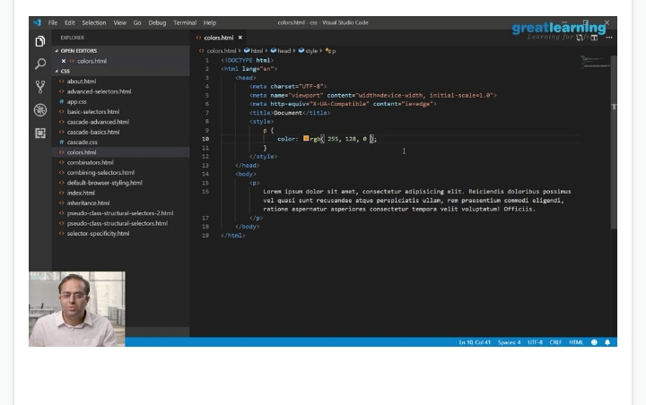

3) coding challenges

#include<stdio.h>

#include<stdlib.h>

void find2RepetElement (int arr1[], int arr_size)

{

int i, j;

printf("The repeating elements are: ");

for(i = 0; i < arr_size; i++)

for(j = i+1; j < arr_size; j++)

if(arr1[i] == arr1[j])

printf(" %d ", arr1[i]);

}

int main()

{

int arr1[] = {2, 7, 4, 7, 8, 3, 4};

int ctr = sizeof(arr1)/sizeof(arr1[0]);

int i;

//------------- print original array ------------------

printf("The given array is : ");

for(i = 0; i < ctr; i++)

{

printf("%d ", arr1[i]);

}

printf("\n");

find2RepetElement(arr1, ctr);

return 0;

}

|  |
| --- |
|  |
|  |  |
|  |  |
|  |  |
|  |  |
|  |  |